


Manage intoxicated persons
D1.HBS.CL5.17
D1.HSS.CL4.07
Trainee Manual




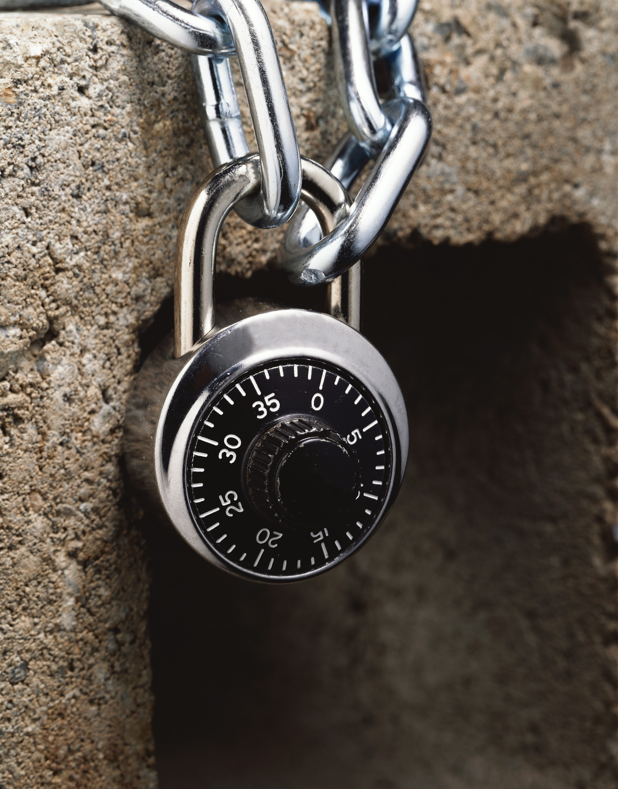

Manage intoxicated persons

D1.HBS.CL5.17
D1.HSS.CL4.07

Trainee Manual




Project Base
William Angliss Institute of TAFE
555 La Trobe Street
Melbourne 3000 Victoria
Telephone: | (03) 9606 2111
Facsimile: | (03) 9670 1330
Acknowledgements
Project Director: | Wayne Crosbie
Chief Writer: | Alan Hickman
Subject Writer: | Nick Hyland
Project Manager: | Alan Maguire
Editor: | Jim Irwin
DTP/Production | Daniel Chee, Mai Vu, Jirayu Thangcharoensamut, Kaly Quach

The Association of Southeast Asian Nations (ASEAN) was established on 8 August 1967. The Member States of the Association are Brunei Darussalam, Cambodia, Indonesia, Lao PDR, Malaysia, Myanmar, Philippines, Singapore, Thailand and Viet Nam.
The ASEAN Secretariat is based in Jakarta, Indonesia.
General Information on ASEAN appears online at the ASEAN Website: www.asean.org.
All text is produced by William Angliss Institute of TAFE for the ASEAN Project on “Toolbox Development for Priority Tourism Labour Division”.
This publication is supported by the Australian Government’s aid program through the ASEAN-Australia Development Cooperation Program Phase II (AADCP II).
Copyright: Association of Southeast Asian Nations (ASEAN) 2012.
All rights reserved.
Disclaimer
Every effort has been made to ensure that this publication is free from errors or omissions. However, you should conduct your own enquiries and seek professional advice before relying on any fact, statement or matter contained in this book. The ASEAN Secretariat and William Angliss Institute of TAFE are not responsible for any injury, loss or damage as a result of material included or omitted from this course. Information in this module is current at the time of publication. Time of publication is indicated in the date stamp at the bottom of each page.
Some images appearing in this resource have been purchased from stock photography suppliers Shutterstock and iStockphoto and other third party copyright owners and as such are non-transferable and non-exclusive. Clip arts, font images and illustrations used are from the Microsoft Office Clip Art and Media Library. Some images have been provided by and are the property of William Angliss Institute.
Additional images have been sourced from Flickr and SXC and are used under Creative Commons licence: http://creativecommons.org/licenses/by/2.0/deed.en

File name: TM_Manage_intoxicated_persons_refined





Table of Contents
Introduction to trainee manual 1
Unit descriptor 3
Assessment matrix 5
Glossary 7
Element 1: Determine the level of intoxication 9
Element 2: Apply appropriate procedures 23
Element 3: Comply with legislation 37
Presentation of written work 47
Recommended reading 49
Trainee evaluation sheet 51
Trainee self-assessment checklist 53

Introduction to trainee manual

To the Trainee
Congratulations on joining this course. This Trainee Manual is one part of a ‘toolbox’ which is a resource provided to trainees, trainers and assessors to help you become competent in various areas of your work.
The ‘toolbox’ consists of three elements:
- A Trainee Manual for you to read and study at home or in class
- A Trainer Guide with Power Point slides to help your Trainer explain the content of the training material and provide class activities to help with practice
- An Assessment Manual which provides your Assessor with oral and written questions and other assessment tasks to establish whether or not you have achieved competency.
The first thing you may notice is that this training program and the information you find in the Trainee Manual seems different to the textbooks you have used previously. This is because the method of instruction and examination is different. The method used is called Competency based training (CBT) and Competency based assessment (CBA). CBT and CBA is the training and assessment system chosen by ASEAN (Association of South-East Asian Nations) to train people to work in the tourism and hospitality industry throughout all the ASEAN member states.
What is the CBT and CBA system and why has it been adopted by ASEAN?
CBT is a way of training that concentrates on what a worker can do or is required to do at work. The aim is of the training is to enable trainees to perform tasks and duties at a standard expected by employers. CBT seeks to develop the skills, knowledge and attitudes (or recognise the ones the trainee already possesses) to achieve the required competency standard. ASEAN has adopted the CBT/CBA training system as it is able to produce the type of worker that industry is looking for and this therefore increases trainees’ chances of obtaining employment.
CBA involves collecting evidence and making a judgement of the extent to which a worker can perform his/her duties at the required competency standard. Where a trainee can already demonstrate a degree of competency, either due to prior training or work experience, a process of ‘Recognition of Prior Learning’ (RPL) is available to trainees to recognise this. Please speak to your trainer about RPL if you think this applies to you.
What is a competency standard?
Competency standards are descriptions of the skills and knowledge required to perform a task or activity at the level of a required standard.
242 competency standards for the tourism and hospitality industries throughout the ASEAN region have been developed to cover all the knowledge, skills and attitudes required to work in the following occupational areas:
- Housekeeping
- Food Production
- Food and Beverage Service
- Front Office
- Travel Agencies
- Tour Operations.
All of these competency standards are available for you to look at. In fact you will find a summary of each one at the beginning of each Trainee Manual under the heading ‘Unit Descriptor’. The unit descriptor describes the content of the unit you will be studying in the Trainee Manual and provides a table of contents which are divided up into ‘Elements’ and ‘Performance Criteria”. An element is a description of one aspect of what has to be achieved in the workplace. The ‘Performance Criteria’ below each element details the level of performance that needs to be demonstrated to be declared competent.
There are other components of the competency standard:
- Unit Title: statement about what is to be done in the workplace
- Unit Number: unique number identifying the particular competency
- Nominal hours: number of classroom or practical hours usually needed to complete the competency. We call them ‘nominal’ hours because they can vary e.g. sometimes it will take an individual less time to complete a unit of competency because he/she has prior knowledge or work experience in that area.
The final heading you will see before you start reading the Trainee Manual is the ‘Assessment Matrix’. Competency based assessment requires trainees to be assessed in at least 2 – 3 different ways, one of which must be practical. This section outlines three ways assessment can be carried out and includes work projects, written questions and oral questions. The matrix is designed to show you which performance criteria will be assessed and how they will be assessed. Your trainer and/or assessor may also use other assessment methods including ‘Observation Checklist’ and ‘Third Party Statement’. An observation checklist is a way of recording how you perform at work and a third party statement is a statement by a supervisor or employer about the degree of competence they believe you have achieved. This can be based on observing your workplace performance, inspecting your work or gaining feedback from fellow workers.
Your trainer and/or assessor may use other methods to assess you such as:
- Journals
- Oral presentations
- Role plays
- Log books
- Group projects
- Practical demonstrations.
Remember your trainer is there to help you succeed and become competent. Please feel free to ask him or her for more explanation of what you have just read and of what is expected from you and best wishes for your future studies and future career in tourism and hospitality.

Unit descriptor
Manage intoxicated persons
This unit deals with the skills and knowledge required to Manage intoxicated persons in a range of settings within the hotel and travel industries workplace context.
Unit Code:
D1.HBS.CL5.17
D1.HSS.CL4.07
Nominal Hours:
10 hours

Element 1: Determine the level of intoxication
Performance Criteria
1.1 Assess intoxication levels of customers
1.2 Offer assistance to intoxicated customers politely
1.3 Refer difficult situations to an appropriate person within or outside of the establishment
1.4 Seek assistance from appropriate people for situations which pose a threat to safety or security of colleagues, customers or property

Element 2: Apply appropriate procedures
Performance Criteria
2.1 Analyse situation carefully
2.2 Apply procedures appropriate to the situation and in accordance with organisational policy
2.3 Explain the position to the customer using appropriate communication skills
2.4 Assist the customer to leave the premises if necessary

Element 3: Comply with legislation
Performance Criteria
3.1 Assess situations
3.2 Deal with intoxicated persons appropriately
3.3 Deal with underage drinkers
3.4 Comply with legislative requirements

Assessment matrix
Showing mapping of Performance Criteria against Work Projects, Written Questions and Oral Questions
The Assessment Matrix indicates three of the most common assessment activities your Assessor may use to assess your understanding of the content of this manual and your performance - Work Projects, Written Questions and Oral Questions. It also indicates where you can find the subject content related to these assessment activities in the Trainee Manual (i.e. under which element or performance criteria). As explained in the Introduction, however, the assessors are free to choose which assessment activities are most suitable to best capture evidence of competency as they deem appropriate for individual students.
 |  |  | Work Projects | Written Questions | Oral Questions
Element 1: Determine the level of intoxication
1.1 | Assess intoxication levels of customers |  | 1.1 | 1,2 | 1
1.2 | Offer assistance to intoxicated customers politely |  | 1.2 | 3,4 | 2
1.3 | Refer difficult situations to an appropriate person within or outside of the establishment |  | 1.3 | 5 | 3
1.4 | Seek assistance from appropriate people for situations which pose a threat to safety or security of colleagues, customers or property |  | 1.4 | 6 | 4
Element 2: Apply appropriate procedures
2.1 |  | Analyse situation carefully | 2.1 | 7 | 5
2.2 |  | Apply procedures appropriate to the situation and in accordance with organisational policy | 2.2 | 8,9,10 | 6
2.3 |  | Explain the position to the customer using appropriate communication skills | 2.3 | 11,12,13 | 7
2.4 |  | Assist the customer to leave the premises if necessary | 2.4 | 14 | 8
Element 3: Comply with legislation
3.1 | Assess situations |  | 3.1 | 15 | 9
3.2 | Deal with intoxicated persons appropriately |  | 3.2 | 16 | 10
3.3 | Deal with underage drinkers |  | 3.3 | 17,18 | 11
3.4 | Comply with legislative requirements |  | 3.4 | 19,20 | 12

Glossary
Term | Explanation
Alcohol | Produced by yeast fermentation of certain carbohydrates, as grains, molasses, starch, or sugar. Whiskey, gin, vodka, or any other intoxicating liquor containing this liquid.
Binge drinking | Practice of drinking too much in a short period of time or in one-off episodes
DJ | Disc Jockey; person responsible for playing recorded music at a venue
Duty of care | Responsibility to ensure that all people are safe from harm
Environment | The immediate surroundings of the premises
External persons | People not employed by the business
House policy | Rule and regulations of an establishment
identification | Approved document to identify a person
Internal persons | People employed by the business
Intoxication | Person is affected by alcohol
Legislation | Laws and regulations of a country
Minor | Person under the legal drinking age
Mocktail | A cocktail style beverage containing no alcohol
Obligation | A legal and or moral right to do something or act in a specific manner
Standard Drink | A beverage that contains 10 grams of pure alcohol

Element 1:
Determine the level of intoxication

1.1 Assess intoxication levels of customers

Introduction
Many hospitality venues serve alcohol in their various food and beverage outlets. It is part of most cultures that alcohol is served, with or without meals.
Whilst for the most parts customers are able to enjoy themselves and drink in a responsible manner, this is not always the case.
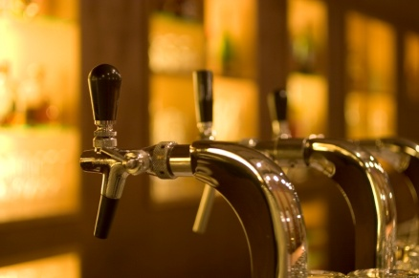
The purpose of this manual is to enable hospitality staff to:
- Understand the legal implications when serving alcohol
- Understand their responsibilities in relation to the service of alcohol
- Handle situations where people are intoxicated.
It is quite common that all staff who work in an environment where alcohol is served must undertake some training in the responsible service of alcohol. This is commonly known as RSA.

Duty of care
Whilst the various legal obligations regarding the service of alcohol will be explained in later parts of the manual, the primary responsibility a business has is to ensure the health and safety of those who either frequent an establishment or are impacted due to its existence.
Every business, regardless of what it sells owes a duty of care to its customers. It is not a new concept and is one that applies in every country.

In this situation, managers and staff have a duty of care to make sure that all people are safe from harm when on the premises as well as when they leave.
This duty of care is owed to all people in the environment including:
- Customers
- Owners
- Managers
- Staff
- General Public.
This means that employers have the responsibility to ensure a safe workplace as well as safe systems of work in their workplace. Not serving alcohol responsibly may put your staff at risk.

Reasons for responsible service of alcohol
Whilst ensuring compliance with the law is a major reason for establishing responsible service of alcohol standards and procedures in a work place, there are many other good reasons for the practice.
In fact, there are no benefits for a hospitality organisation to encourage customers to be drunk.
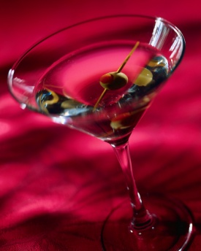
Benefits to the business:
- Enhances reputation – as you are seen as a responsible provider
- Reduces fines and liability on the business, managers and individual staff members
- Allows the business to remain operational
- Increases business and profits as people feel comfortable visiting your establishment
- Less likely to have damage to the premises due to breakages, spillage, vomit
- Reduces costs to repair broken items
- Creates order and improve the ambience of a venue
- Reduces staff and security costs due to reduced need to handle drunk patrons
- Reduces liability and insurance costs
- Reduces legal claims and associated costs.
Benefits to staff:

- Less stress for staff
- Less potential harm or threatening actions
- Enables easier communication with customers
- Less work for staff
- Creates a safe and harmonious work place for all staff and customers
- Increases job satisfaction and security – staff will feel more comfortable working in a venue that is void of alcohol related stress and violence.

Benefits to customers:

- Reduces chance of customers hurting themselves or others
- Allows the atmosphere and experience of fellow customers to be positive
- Reduces violent or threatening behaviour
- Reduces crimes and domestic violence
- Reduces drink driving which is a leading cause of road and pedestrian accidents.

Alcohol
Alcohol is a substance that has become an everyday part of society, however what it is and how it affects the body is often not discussed.
The intoxicating ingredient in alcoholic beverages is known as ethyl alcohol or pure alcohol. This ingredient is contained in all alcoholic drinks; however the level of concentration differs between drinks. The strength of alcoholic drinks varies. Even a specific alcoholic beverage such as beer will have different strengths. For example, beer can range from about 2% to about 9% alcohol by volume (ABV).
In order to make measurement as uniform as possible, the agreed convention for standardising drinks is ‘grams of pure alcohol’ What it means in practice is that a “standard” drink will always contain a given amount of pure alcohol, regardless of whether it is beer, wine or spirits.
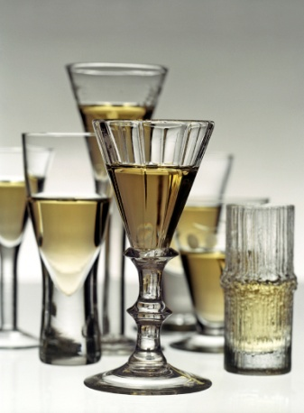
A standard drink
A standard drink is commonly defined as a beverage that contains 10 grams of pure alcohol. This may vary between 8 and 14 grams in different countries, whilst some countries do not identify a ‘standard drink’.
As a general rule, a standard drink can be defined as:
- 30 mls of sprits
- 285mls of full strength beer
- 100mls of wine.
In reality, most alcoholic drinks are not served as a neat ‘standard drink’. The size of the glass and pouring size may mean a drink contains more than 1 standard drink or 10 grams of alcohol.

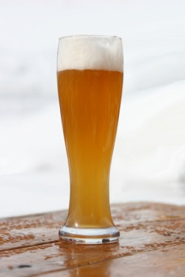
For example:
- A 330ml bottle of beer (5% ABV) may contain 13.2 grams of alcohol / 1.3 standard drinks
- A 200ml glass of wine (12% ABV) may contain 19.2 grams of alcohol / 1.9 standard drinks
- A 568ml (pint) of beer (4% ABV) may contain 18.2 grams of alcohol / 1.8 standard drinks.
A formula for working out how many grams of alcohol / standard drinks in a beverage is:
{Amount of drink (ml) X Strength of drink (ABV)} x 8
1000

Effects of alcohol
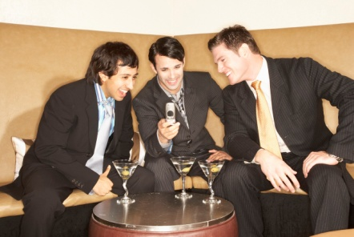
Many people enjoy visiting hospitality organisations as it provides a chance for people to relax, unwind and enjoy themselves through the provision of good food, beverage and entertainment.
In today’s society, alcohol is so widely available that many people forget that it is still a depressant drug.
Whilst for most people, drinking in moderation and in a responsible manner, will not lead to someone becoming depressed, it is still important to remember that alcohol does depresses the brain’s functions which leads to changes in a person’s behaviour.
When consumed in an irresponsible manner alcohol can become a dangerous and damaging substance which can have serious effects on a person.
Therefore as a staff member within the hospitality industry, it is important that you ensure customers consume alcohol in a sensible manner and understand the effect alcohol has on people.
So how does alcohol affect the body?
Alcohol and the body
Alcohol entering body
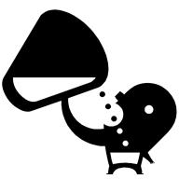
Alcohol, when consumed it is normally swallowed and goes into the stomach. The stomach breaks down food and drink before passing it to the small intestine. It is then absorbed into the bloodstream. The less food the quicker it is absorbed. The bloodstream then carries the alcohol to the brain. This process takes about 5 minutes and starts to affect the function of the brain including judgement and inhibitions.
As more alcohol is absorbed, it continues to travel to other parts of the body affecting other functions including balance and co-ordination. It is this effect that starts to make us appear to be drunk.

Alcohol leaving body
The liver is the main organ that removes alcohol from the bloodstream. It takes about 20 minutes for alcohol to reach the liver. Generally the liver removes alcohol at the rate of one standard drink per hour.
Alcohol affects people differently
Whilst alcohol enables people to relax and enjoy themselves, it can lead to people losing control to some degree of their behaviour and actions.
In essence, alcohol affects different people in different ways due to:

- Speed of drinking
- Strength of drink - the blood alcohol concentration (BAC).
- Person’s sex - women are more affected than men
- Person’s weight - a small person is more affected than a big person
- Amount of food eaten - a person who has empty stomach is more affected than a person who has eaten a big meal
- Tolerance to alcohol - a person who drinks rarely will appear more affected than a person who drinks regularly.
As a staff member, it is important to know the early symptoms of intoxication and to refuse to serve such customers well before they become obviously drunk.
As alcohol worsens the physical and mental functioning, the more individuals drink, the less likely they are to be able to make decisions about their own well-being. This is why it is up to the server to decide who has had enough to drink, not the drinking customer.

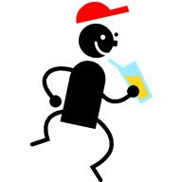
What is intoxication?
Different countries will prohibit the sale or supply or alcohol to someone who appears to be intoxicated or drunk. By what does this mean? When do you know someone has reached this level?
In summary, “intoxicated” is the body’s response to having alcohol in the human system. This is always hard to identify so what signs exist that may indicate intoxication?

Signs of intoxication
The following signs can give you an idea of whether or not a person is intoxicated. Signs of intoxication include:

Loss of coordination
- Being clumsy
- Eyes seem unfocused or glassy
- Bumping into furniture and other people
- Staggering
- Falling down or tripping over things
- Inability to walk in a straight line
- Inability to do basic tasks like lifting a glass
- Knocking things over.
Change in speech
- Having trouble talking in a normal manner
- Speech becomes slower and slurred
- Volume of speech becomes louder

- Person becomes outspoken.
Moods, behaviour and conduct
- Big changes in mood over time.
- Personality changes
- Becoming isolated from group
- Inappropriately affectionate
- Extremely outgoing
- Wanting to cause arguments
- Being over affectionate to strangers.

Quantity of alcohol consumed
- The amount of drinks consumed
- The rate of consumption
- They are ordering more drinks at a time
- The types of drinks – normally become stronger
- Complaints about strength of drinks.

Smell of alcohol
It is safe to assume a good indicator of intoxication is if a person has a strong smell of alcohol, combined with any of the before mentioned signs.

Body language
Understanding body language is a very effective way to determine the intoxication of a person and the manner in which the situation may be addressed.
In previous points, it was stated that a change in behaviour and mood is often a sign of intoxication, however being able to read a person’s body language will also produce helpful signs.
So what does a person’s body language tell us about someone? Following is a helpful chart that helps explain a person’s body language.
Reading body language:
 | Aggressive (angry) | Assertive (in control) | Passive (weak)
Posture | Leaning forward | Upright or straight | Shrinking
Head | Chin out | Firm | Head down
Eyes | Strong focus, piercing, staring | Good, regular eye contact | Looking down or away, little eye contact
Face | Set or firm | Suitable expressions | Smiling even when upset
Voice | Loud and emphatic | Calm and clear | Hesitant or soft
Arms / Hands | Hands on hips, fists, sharp gestures, pointing, jabbing | Relaxed, moving easily, open palms | Aimless and still
Movement / Walking | Slow and pounding, fast and deliberate | Measured pace | Slow and hesitant, fast and jerky

Tool to help identify intoxication

Whilst the previously mentioned signs of intoxication will help a staff member identify an intoxicated person, a tool can help staff members identify is a person is intoxicated is:
Coordination
Alcohol Smell
Unsteady
Slurred Speech
Eyes Glazed
Once you have identified that a customer is intoxicated, it is your responsibility to act in a prompt and appropriate manner.

1.2 Offer assistance to intoxicated customers politely

Introduction
When it is determined that a person is intoxicated, it is wise for staff to provide assistance where applicable, in line with company policies and relevant legislation.
Just because someone is intoxicated does not mean they need to leave the premises. There are a range of suitable alternatives that can be provided depending on the individual situation and level of intoxication.
It is important to remember that each situation must be handled in a professional and discrete manner. No person likes to be told they are intoxicated or being given instructions on how to enjoy their experience, so where possible the dignity of the intoxicated person must be upheld.

Monitor the environment
Staff members must always be aware of the environment and alert to the consumption of alcohol by groups or individual customers within the establishment.
Being able to deal with any potential problems as early as possible, will hopefully avoid situations that may put staff and customers at risk or reduce the enjoyment of the venue by others.
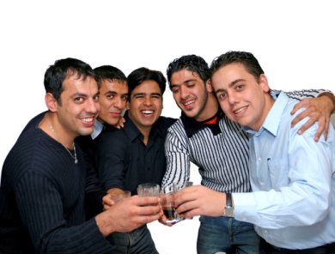
When monitoring, be aware of:
- Types of drinks being ordered
- Who is ordering the drinks
- Who is consuming the drinks
- Rate of consumption
- Whether food is also being consumed
- People showing signs of intoxication
- Any drinking games being conducted
- Which people in the group could be of assistance when dealing with intoxicated patrons.

Types of assistance
Depending on the level of intoxication of the customer there are a number of ways assistance can be offered, either directly or indirectly advised to the customer, to enable the customer to stay on the premises.
These include:
- Talk to the customer or their friend – this helps determine not only the level of intoxication, but how they will respond to suggestions that may be suitable
- Briefly explain your responsibilities – you may wish to outline the house policy that applies, directly to the customer or a friend of theirs. Try to get the person on your side by explaining that whilst you would like the customer to stay on the premises, they must abide by the rules of the establishment
- Promoting non-alcoholic drinks – most venues will have a range of soft drinks, juices or mocktails which can be a suitable alternative to alcohol
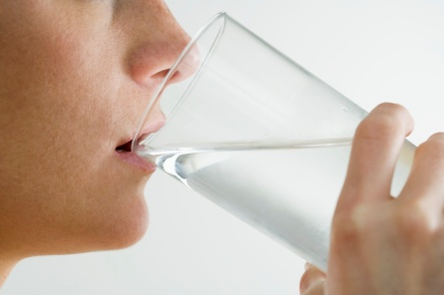
- Offering low-alcoholic beverages – some beverages such as beer come in a low alcoholic format which can be promoted. Alternatively half measures may be suggested when serving spirits
- Offer water – water is free of charge in most facilities. You may suggest a customer having a glass of water between alcoholic drinks or for a specific period of time
- Offer food – whether through providing a menu or offering complimentary or low costs snacks such as nuts and chips
- Slowing down service – try to delay the service of drinks to a person, however this should not be obvious as it may frustrate the customer
- Advise other staff – as to the amount of drinks the person has had or any concerns which you may have.
Steps on how to correctly handle intoxicated patrons and matters involving high levels of intoxication will be discussed in a later section.

1.3 Refer difficult situations to an appropriate person within or outside of the establishment

Introduction
As customers become more intoxicated, the more difficult it may be to handle the situation yourself. In many cases customers will understand the rules that apply and will abide by them in order to enjoy their time on the premises.
This is not always the case. At times situations may have got out of control resulting in other people being needed to bring the situation under control.

Appropriate internal persons
It must be remembered, that the health and safety of staff, other customers and the intoxicated person themselves is the primary objective when handling instances involving intoxication.
As a staff member, it is not a requirement for you to place yourself in harm’s way if you feel you cannot handle the situation.
There are a number of appropriate people who can be called upon to provide assistance or to handle difficult situations involving alcohol.

These persons include:
- Supervisor or Manager – they will make or authorise courses of action to take
- Security – they will have the expertise to deal with the manner
- DJ – they have the capacity to communicate not only with different authorities but can also communicate directly to the patrons within the venue.
Remember, if you feel you cannot handle a situation yourself, be smart and seek suitable support to handle any situation where you feel you are in harm.
Suitable external persons to notify will be discussed in the next section.

Reaching appropriate internal persons
There must be an easy to use communication system to be able to notify appropriate internal people. Systems can include:
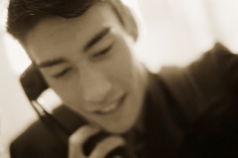
- Pagers
- Signals – verbal or hand
- Button
- Phone call.

1.4 Seek assistance from appropriate people for situations which pose a threat to safety or security of colleagues, customers or property

Introduction
As stated in the last section, if a situation appears to be out of control it is important that the correct person or authority is called.
Whilst using internal sources of assistance are the first course of action, at times the situation may have gotten out of control and more serious action needs to be taken.
Every organisation should have a designated set of instructions and procedures to follow in the event of a variety of situations ranging from arguments, spiking of drinks, violence or medical harm, to name a few.
Staff must be aware of which type of assistance to contact whenever these situations arise.
Anytime a situation poses a risk it must be dealt with in a prompt manner abiding by all the laws required by the country.

Appropriate external persons
In the previous section a range of internal persons to contact were identified.

There are a number of suitable external sources that can be contacted including:
- Police – in the event of any activity that is breaking the law or likely to increase the risk of harm to all patrons and staff
- Fire – if there appears to be a likelihood of fire
- Ambulance – in the event a person requires medical assistance.

Reaching suitable external assistance
As stated in the last section, if a situation appears to be out of control it is important that the correct person or authority is called in a prompt manner.
Not only should managers state situations when each appropriate source of assistance should be notified, but also how to contact them.
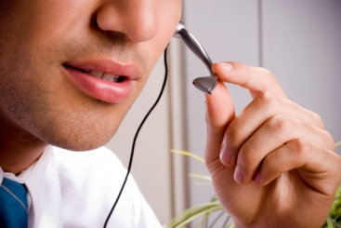
Easy to reach contact details can include:
- Special button
- Posters with contact numbers
- Speed dials
- Other methods that are suitable.

Work Projects
It is a requirement of this Unit you complete Work Projects as advised by your Trainer. You must submit documentation, suitable evidence or other relevant proof of completion of the project to your Trainer by the agreed date.
1.1 To fulfil the requirements of this Work Project you are asked to research and identify how to assess intoxication levels of customers including:
Duty of care
Reasons for responsible service of alcohol
Alcohol content in drinks
Effects of alcohol
Definition of intoxication
Signs of intoxication
Tool to help identify intoxication.
1.2 To fulfil the requirements of this Work Project you are asked to research and identify how to offer assistance to intoxicated customers politely by:
Monitor the environment
Utilising different types of assistance.
1.3 To fulfil the requirements of this Work Project you are asked to research and identify how to refer difficult situations to an appropriate person within or outside of the establishment including:
Appropriate internal persons
Reaching appropriate internal persons.
1.4 To fulfil the requirements of this Work Project you are asked to research and identify how to seek assistance from appropriate people for situations which pose a threat to safety or security of colleagues, customers or property including:
Appropriate external persons
Reaching suitable external assistance.

Summary

Determine the level of intoxication
Assess intoxication levels of customers
Duty of care
Reasons for responsible service of alcohol
Alcohol
Effects of alcohol
What is intoxication?
Signs of intoxication
Tool to help identify intoxication.
Offer assistance to intoxicated customers politely
Monitor the environment
Types of assistance.
Refer difficult situations to an appropriate person within or outside of the establishment
Appropriate internal persons
Reaching appropriate internal persons.
Seek assistance from appropriate people for situations which pose a threat to safety or security of colleagues, customers or property
Appropriate external persons
Reaching suitable external assistance.

Element 2:
Apply appropriate procedures

2.1 Analyse situation carefully

Introduction
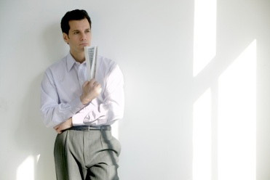
The manager plays a pivotal role in ensuring the venue is safe for all staff and patrons to enjoy. They have control over what will be determined acceptable behaviour and actions within a venue and how it should be run to ensure patrons can enjoy the facility.
Their decisions and actions guide the atmosphere of a venue. In essence the atmosphere is the general mood or feeling of a place. It influences the behaviour and actions of customers and influences the way they drink and their ongoing behaviour.
Part of creating the right atmosphere is about encouraging people to behave in a manner that is in keeping with the style of your premises. To do this, managers must set standards which must be explained and communicated with all staff.

Drinking behaviour
Drinking behaviour is the greatest influence on how each person’s behaviour and actions, the way a group interacts and the general conduct within the premises.
By promoting, encouraging and controlling the drinking behaviour, it will certainly help reduce the risks associated with intoxication.
Drinking behaviour depends on three different factors:
- The drink - the amount and strength of alcohol
- The drinker - the characteristics of the person drinking the alcohol and his or her state of mind and personal circumstances
- The environment - the atmosphere and prevailing rules of the establishment where the drinking is taking place. This could be a sports area, dancing area or a quieter dining or bistro area. The layout of the premises, whether there are more people sitting or standing, the lighting and the music are all things that create the drinking environment.
Removing or changing any one of these factors will alter the drinking behaviour.
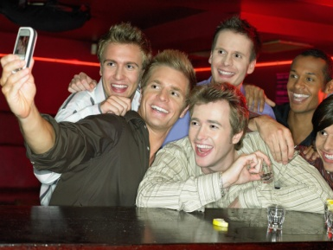
It is a fine balance, however managers must try to let people let their hair down, whilst not going over the top and endangering other patrons or staff.
Evidence suggests that where is louder music and people are standing, people are likely to drink quicker, than if they were seating in a quieter location. The environment that you set can influence whether the customer is more likely to drink in a relaxed, social way or in an aggressive or competitive way.

Creating the right environment
There have been many studies conducted in different countries that have mutually agreed there are a number of factors that influence drinking behaviour and the change and degree of problems associated with intoxication.
The study found that there is a range of factors, both positive and negative, that increase or reduce the chance of alcohol related problems in an establishment.
Whilst a manager and staff can assess the situation as it happens, the best way to reduce the negative effects of alcohol is to create the right environment before actual patrons arrive.
Whilst it is impossible that all alcohol related problems can be avoided, having the right atmosphere will certainly make the venue a more comfortable and appealing place for managers, staff, patrons and the community alike.

Positive factors
Having a venue that is safe for patrons to use is not only helpful in reducing negative incidents as a result of alcohol, but can be a great promotional tool to encourage patrons who are confident in the venue.
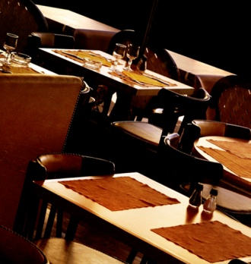
Some ways to establish a safe venue include:
- High levels of cleanliness
- Facilities in operational order
- Good security measures
- Regular removal or rubbish and waste
- Prompt cleaning of tables and removal of dirty bottles, plates and glasses
- Adequate and well lit and ventilated toilets
- Video camera surveillance
- Non-aggressive security staff

- Non-crowding policies
- Mix between men and women
- Well trained and professional staff
- Good communication
- Good activities
- Safe venue layout.

Negative factors
There are a number of factors that are known to increase the changes of alcohol related and other associated problems including:
- Unsupervised pool tables
- TV showing aggressive, offensive, sexual or intoxication-related images
- Music with a lot of offensive or sexually explicit words

- Congestion anywhere in the premises (at the door, bar, stairs, toilets, dance floor, etc.)
- Higher percentage of customers standing
- Drunk or underage persons allowed in and served
- Vomiting
- Drug dealing or drug use
- Drunk customers in the premises
- Staff being hostile or aggressive towards patrons
- Staff allowing aggression or watching conflict

- Staff sending people outside to fight
- Late intervention in situations by staff
- Patrons served double at closing time or served after closing time
- Smokiness and/or lack of ventilation
- High level of noise and movement
- Lack of bar wiping, table clearing, toilet cleanliness
- Openly sexual or sexually competitive activity
- In-house promotion or entertainment focusing on alcohol and “sexy dancing”.

Assessing the situation

Once the above risks have been addressed and action taken to create the right atmosphere, this does not guarantee problems will not arise.
It is vital that not only managers, but all staff constantly assess and monitor the situation as the shift unfolds. Each and every staff member, including bar staff, waiters, security, cleaners or music related employees, keep a watch out for any behaviour that may indicate trouble is likely to take place.

2.2 Apply procedures appropriate to the situation and in accordance with organisational policy

Introduction
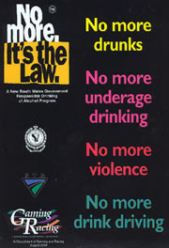
Every organisation that serves alcohol should have established policies and procedures that are in place to help promote the responsible service and consumption of alcohol.
Each country and local administrative region will have their own laws and regulations in relation to the supply and service of alcohol and how to handle intoxicated patrons.
It is essential that anyone who will be involved in the supply or sale of alcohol understand all laws and regulations that apply in your region or country.
Whilst the information provided in this manual identifies key strategies and actions that are commonly used on a global scale, any local laws or regulations will always take precedence over this information.
In the next two sections, specific steps are identified in how to handle intoxicated persons; however it is vital that certain mechanisms are in place to support these actions.

Establish a house policy
One of the most powerful ways of reducing the risks of a breach of your duty of care or local laws and regulations is to have a house policy that is visible and always applied in the venue.
This is the best way to inform both staff and customers about the laws and rules of a specific organisation. It creates a framework for how an organisation will promote the safe supply and consumption of alcohol.
A house policy clearly states your commitment to harm minimisation and the responsible serving of alcohol.

Although general policies are available, the best are those that fit the venue because they are written by and unique to the venue.
The following should be included in a house policy:
- Expected standards of behaviour of customers.
- A list of those not to be served alcohol
- Limits for cocktails, shots or shooters.
Getting the input and suggestions of staff is highly encouraged as they will be the people who will be putting the strategy into place. They must feel comfortable about what is required of them. It also means they will have more ownership and are more likely to always apply the principles of RSA in the venue.
Send out a copy of your House Policy with each function confirmation. Let customers know what you expect before they arrive.
As part of an induction programme or code of conduct, staff should be provided with guidelines on acceptable behaviour whilst on the premises and particularly, when providing service to patrons.

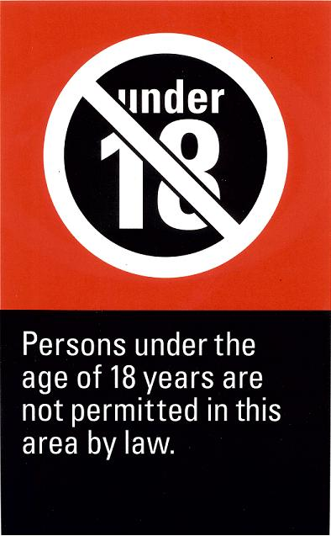
Signage
Most laws will require or encourage a premise to have suitable signage placed in locations that can be seen by customers and referred by staff.
Having these signs in clear view is extremely helpful as it allows staff to refer to them when appropriate action is taken in reference to intoxication. It is important that they understand the content and ramifications of the information contained within the signs.

Escalation Plan
Have an “escalation plan”. That is, a plan for if things get worse. This is likely to include communicating the problem to other staff and may involve calling the police.
By having a plan which is understood by all staff members before an incident takes place, there is a clear path of responsibilities and actions that can guide a very stressful time.

Identify and address current issues
Drink spiking
This is where alcohol or other substances is added to drinks without the drinker’s knowledge or consent.
Drink spiking is currently an issue that is causing serious concern among health professionals and police as it can be related to other crime such as sexual assault.
Whilst it is often associated with other drugs, it also extends to putting shots of spirits into drinks or ordering drinks with extra shots for other people.
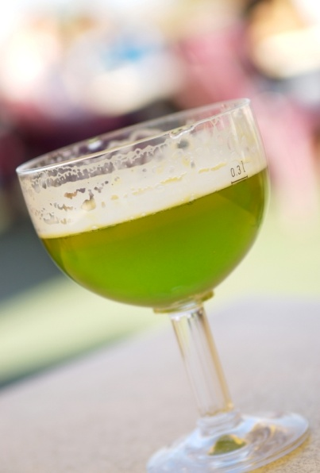
Management and staff must be careful to notice incidents of drink spiking and should develop strategies that reduce the opportunity for drink spiking to occur.
It should be remembered that it is a crime punishable by fines and imprisonment.
Strategies to avoid drink spiking:
- Warn customers not to leave drinks unattended
- Have a policy regarding the maximum number of shots per drink, even in cocktails
- Dispose of unattended drinks
- Be suspicious of orders for drinks with added shots of spirits and have a policy in place to deal with them
- Watch the behaviour of patrons, looking for signs that a person has become suddenly drunk. Take notice of people offering to take the affected person home.

Binge drinking
Binge drinking is a very harmful practice of drinking too much in a short period of time or in one-off episodes. Young people are particularly at risk as they may not have access to alcohol over the long term, but get hold of it only occasionally.
Binge drinking can lead to aggression, domestic violence, health issues, unsafe sex and sexual assault.
Following responsible service of alcohol practices can reduce the incidence of binge drinking and underage drinking which is often associated with binge drinking.
Research has shown that a majority of all alcohol consumed, especially by younger people, is drunk in a manner that is dangerous to health through habits such as binge drinking and drinking on more than five days per week.
However, it is most common in the 18-24 years age group with over 93% of alcohol drunk by males liable to cause health problems and 82% for young women.
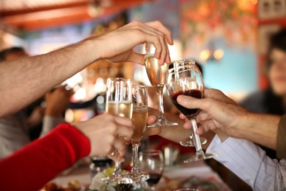

2.3 Explain the position to the customer using appropriate communication skills

Introduction
When handling intoxicated persons, there are a number of approaches that can be taken, depending on the individual situation and severity of the problem.
Regardless of the action taken, it is important for staff to be professional and respectful in their approach.
Handing intoxicated people should be done in a sensitive and discreet manner which solves the situation, not escalates it further.

Steps when handling intoxicated customers
The following T-A-K-E C-A-R-E steps can help resolve matters involving intoxicated patrons.
Tell early

Avoid put-downs
Keep calm
Ever courteous
Clarify refusal
Alternatives
Report
Echo
Tell early
If staff are aware of early signs of intoxication, they are able to help provide assistance to customers which enable them to still enjoy their experience. Some of these types of assistance were identified in Section 1.1.
Avoid put-downs
You must be respectful in your approach with people. Do not judge them or talk down to them.
Keep calm
Whilst it is not uncommon for intoxicated persons to talk in a rude manner to you, remember you are just doing your job and try not to take the comments personally. Try to use a calm and controlled voice. You don’t want to use loud or threatening words or tones which can further escalate the problem.

Ever courteous
Regardless of the way that you may be treated by a specific customer, you must respect the customer and be professional and polite.
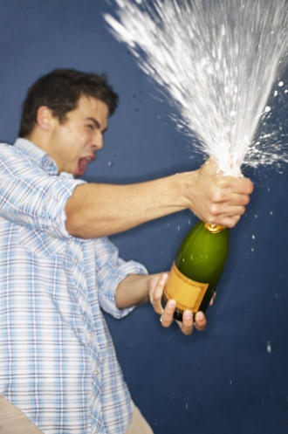
Don’t be confrontational and demeaning about the person. Your role is to explain why you are taking a certain approach. Normally this involves identifying how a person may be breaking the law.
Clarify refusal
You need to explain why a person may be refused a beverage, entry into the premises or the right to remain on the premises. Be practical in your explanation and stick to the facts. Don’t get emotional or personal about the intoxicated patron. You may merely state that at this time, the law requires them to follow a certain action. You may want to remind the person they are welcome back when they abide by the law.
Alternatives
If handled in a prompt manner, a staff member will be able to provide and explain a range of alternatives including switching to soft drinks or eating a meal, which will allow the customer to remain on the premises. At least you have placed some responsibility back in the customer’s hands in relations to their actions.
Report
Ensure other people are aware of what is happening. For legal reasons you may be required to keep a written record of events as they happen and the approach taken.
Echo
You may wish to notify a friend of the intoxicated person why certain actions are taking place. They may be in a more controlled state and understand the situation more clearly. They can also become an ally when dealing with the intoxicated person.
If the customer is a regular, you may wish to explain your actions and the reasons behind it when they next return and in a clearer frame of mind to avoid a re-occurrence.

Handling complaints
Like in any business, there will always be complaints that will be brought to the attention of staff and management.
When alcohol is involved, the number and types of complaints may vary. Some may be logical whilst others unreasonable and resulting from the requests of people who are intoxicated or under the influence of alcohol.
Dealing with a complaint can be complicated. If you handle it well, you will have brought the customer round from being dissatisfied to being happy. However, if dealt with badly, the customer will feel less happy and is likely to tell as many people as possible about the situation, leading to a loss of potential customers.
Quite often intoxicated people will just complain and any solution you may offer, whilst reasonable to you, may never satisfy their needs.

Regardless of the complaint, key points to dealing with them include:
- Listen carefully to the complaint, without interrupting
- Show that you understand
- Apologise
- Seek a solution.
It is important not to remain professional and treat every complaint with respect, even if it does not warrant it.
Remember, when people are angry, they often throw insults. Do not take insults personally or retaliate, you have to remain professional.
Dealing with complaints requires you to have patience and to keep others around you calm.

Handling potential problem situations
As alcohol is associated with relaxing and celebration, there will always be potential problems that arise.
Whilst you can never be sure of situations that may lead to trouble, traditionally there are scenarios than commonly need to be monitored closely. These include:
Large Single Sex Groups
Whether due to celebration or party, single sex groups often start drinking to excess; encourage a culture of drinking games and fast consumption. Due to the nature of large groups, their actions and noise level may impact on other customers as well.
- Distribute house policy with confirmations of large bookings or private functions
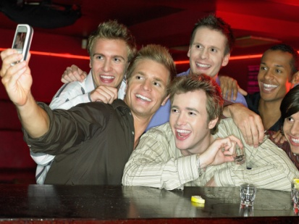
- Speak with them on arrival. Welcome them and thank them for their patronage however notify them of expected behaviour
- Speak with them in a friendly manner and don’t treat them as a problem, until they do become one. Their business is just as important to the business as other customers and they deserve to be treated with respect. In fact you may wish to acknowledge their business and provide some special products or services, given they are a large group who are likely to spend a lot of money
- Build up a relationship early on so it’s easier to speak to them later – find out what they are celebrating
- Set aside a separate area for them, if possible, to avoid upsetting other customers
- Identify the leader and make him or her responsible for the group’s behaviour
- Watch the amount they are drinking
- Speak to individuals at the bar
- Make it clear that, if one person causes trouble, they will all have to leave.

Domestic Arguments
These are often the hardest to spot and to handle as the matter is very personal and important to those involved. It is a common occurrence, which seems to be more common when alcohol is involved. Whilst you can’t listen to each customer’s conversations, it is often obvious if there are ill feeling or cross words being spoken between partners or friends.
- Visit the table, ask if all is ok. The attention and the fact you have noticed are enough to make most quieten down or leave

- If it persists and or gets louder, you will need to ask them once again if they are ok
- Suggest that this is not the place for their upset or argument
- Let them know that, if they can’t put aside their issues, they will have to leave
- Always remain impartial
- Depersonalise the situation by stating it is your job / house rules and nothing personal.
Games and Sports
All games seem to have a winner and a loser. This very nature often leads to one person being upset. In premises where customers are playing games such as pool or darts, there is also the added issue of potential weapons. Issues may also arise with whose turn it is next.
To help reduce potential problems:
- As rules differ from area to area, have a set of house rules for everyone to play by

- Put a clear, fair system in place for how to book games and how to determine who plays next
- Ensure the area is well staffed or has frequent staff presence to spot any potential problems
- Put in place a deposit system or some other method, so all equipment such as darts and cues are returned to staff after each game.

2.4 Assist the customer to leave the premises if necessary

Introduction
There may be times when all previous approaches to allow a customer to remain on the premises have failed and for the best interests and safety of everyone, the intoxicated person may be asked to leave the premises.
Even at this time, staff must remain professional and respectful. This is important, given that it is very likely that the intoxicated person may not be acting in a reasonable manner or may become violent.

When someone is required to leave
It is often a legal requirement that an intoxicated person is not permitted to remain on the premises. Whilst is it unreasonable to ask every patron who is showing even the smallest sign of intoxication to leave, it is essential that a person will be asked to leave who:

- Is using or threatening violence
- Is disturbing the enjoyment of other patrons
- Is disorderly or not abiding by premises rules
- Is breaking the law
- Is using disgusting, profane or foul language.
Some laws state it is actually an offence if a person remains on the premises when asked by management or staff to leave.

Steps when asking someone to leave
- Final warning - The first step may be to give someone a final warning explaining their actions may lead to them being asked to leave.
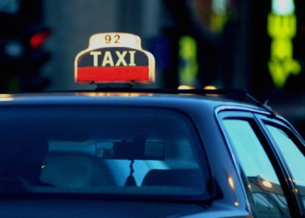
- Notifying friends – you may wish to notify a friend of the intoxicated person what is happening. Intoxicated people are more likely to listen to their own friends than those of authority.
- Identify transportation – you may wish to arrange a taxi for the person or identify suitable transportation, whether it is with one of their friends. Whilst it is not always a legal requirement, you do not want an intoxicated person in a situation where they are roaming the streets or trying to drive themselves home. Not only does this cause potential risk to the community, but may have legal ramifications on the organisation.
- Arrange assistance – before a person is being asked to leave you may wish to call upon others to assist, monitor or actually undertake the process.

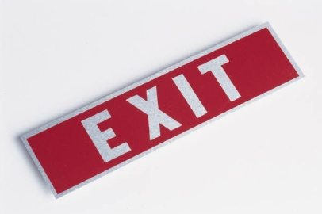
- Explain why the person is being asked to leave – be professional and explain to the person why they must leave the premises. Normally notifying them that they are breaking the law is enough information.
- Explain transportation options – you may wish to notify the person how they will be getting home, once they have left the premises.
- Follow the person to the door – ensure the person has collected all their belongings. Do not touch the person as this may provoke them further and try to keep the process as discreet as possible.
- Ensure the person is safely off the premises – hopefully this is in transportation or they have a friend who can ensure the person gets home safely.
There will be times, when a more direct and forceful action is required; however the appropriate authorities must undertake this action, whether by police or security.
The main priority in this process is ensuring that everyone remains safe. This includes staff and other patrons, but also the intoxicated persons, as quite often they will not be in a physical or mental state to take responsibility for themselves.

Work Projects
It is a requirement of this Unit you complete Work Projects as advised by your Trainer. You must submit documentation, suitable evidence or other relevant proof of completion of the project to your Trainer by the agreed date.
2.1 To fulfil the requirements of this Work Project you are asked to research and identify how to analyse situation carefully including:
Understanding drinking behaviour
Creating the right environment
Positive factors
Negative factors
Assessing the situation.
2.2 To fulfil the requirements of this Work Project you are asked to research and identify how to apply procedures appropriate to the situation and in accordance with organisational policy including:
Establishing a house policy
Using signage
Having an Escalation Plan
Identifying and addressing current issues.
2.3 To fulfil the requirements of this Work Project you are asked to research and identify how to explain the position to the customer using appropriate communication skills including:
Steps when handling intoxicated customers
Handling complaints
Handling potential problem situations.
2.4 To fulfil the requirements of this Work Project you are asked to research and identify how to assist the customer to leave the premises if necessary including:
When someone is required to leave
Steps to take when asking someone to leave.

Summary

Apply appropriate procedures
Analyse situation carefully
Drinking behaviour
Creating the right environment
Positive factors
Negative factors
Assessing the situation.
Apply procedures appropriate to the situation and in accordance with organisational policy
Establish a house policy
Signage
Escalation Plan
Identify and address current issues.
Explain the position to the customer using appropriate communication skills
Steps when handling intoxicated customers
Handling complaints
Handling potential problem situations.
Assist the guest/customer to leave the premises if necessary
When someone is required to leave
Steps when asking someone to leave.

Element 3:
Comply with legislation

3.1 Assess situations

Introduction
As a manager or a server in an establishment that serves alcohol it is your responsibility that it is done in a manner that maintains the health and safety of all people concerned.
Every shift is different however it is important that management and staff conduct operations in a manner that is legal and promotes responsible service and consumption of alcohol.
It is the task of management to create a low risk environment by implementing policies and procedures to encourage responsible service of alcohol.

Responsible & legal considerations
There are a number of actions that a manager must consider when making a venue serving alcohol a safe and legal operation including:
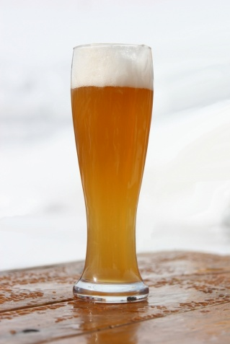
- Establish a house policy covering:
- Laws and regulations
- Responsibilities of staff
- Serving strategies
- Refusal of service
- Avoid promotions that encourage irresponsible consumption of alcohol
- Train staff in responsible service of alcohol
- Identify and address potential difficult situations
- Create the right atmosphere.
These steps have been discussed through the manual, and whilst they are very effective in operating a safe venue, many of these activities are also a legal requirement.

3.2 Deal with intoxicated persons appropriately


Introduction
This manual has identified a variety of ways in which to deal with intoxicated persons, depending on the situation, level of intoxication and risks to others.
Most of these strategies are not only helpful in professionally dealing with intoxicated patrons, but are also legal. This ensures that in the event, an investigation takes place in regards to a particular incident, management and staff can be confident they have followed the correct procedures and help mitigate any legal issue that may arise.

Tips to remember
Whilst a range of legally abiding steps is identified elsewhere in this manual, some important tips to remember include:
- Identify situations where problems may arise as early as possible
- Try to involve the customer by providing options
- Treat the customer professionally
- Don’t touch the customer, where possible
- Take action as early as possible
- Follow all house policies, rules and regulations.
When handling any situation involving an intoxicated individual, always think of how you would like to be treated if the roles were reversed.

3.3 Deal with underage drinkers

Introduction
It is human nature for people who are under the legal age of drinking in a specific country to want to consume alcohol. Be it, peer group pressure, the right to fit in, the act of rebellion or simply wanting to act older than you are, every establishment that serves alcohol, at some stage will need to deal with underage drinkers.
For the purpose of this manual, a person under the legal drinking age will be referred to as a ‘minor’.

Reasons for law
Reasons for having a designated drinking age

Every country will have a designated age in which people are allowed to legally drink alcohol. This is set because the consumption of alcohol by minors is very dangerous. This is because:
- They lack the experience of drinking alcohol
- They may not be mature enough to handle themselves in a drinking capacity
- Brain does not fully develop until the age of 24 in males and 22 in females. Therefore the effects of alcohol impacts brain development to a greater extent
- Their internal organs haven’t fully developed, therefore the effects of alcohol are greater
- Minors are more likely to binge drink, which is a major health risk
- Minors are most likely to become dependent on alcohol and become heavy drinkers later in life.

Conditions for law
The law will also state conditions in which alcohol can be served in relation to minors. Each country will have their own laws in relation to the sale and consumption of alcohol in relation to minors
Some legal conditions may include:
- Alcohol cannot be sold to a person under the legal drinking age
- Alcohol cannot be supplied or consumed by a person under the legal drinking age
- Proof of age must be checked if a person looks under 25 years of age
- Minors may be able to be on a premises that supplies alcohol if:
- They are in the company of a responsible adult
- Are eating a meal
- Work on the premises in duties that do not involve the sale of alcohol
- Some venues may allow a minor to have an alcoholic drink if they are having a meal or with a spouse, parent or guardian
- Food containing alcohol may be consumed if below a certain percentage of the entire meal
- Minors may not be allowed into areas where their primary product sold is alcohol including bars and night clubs.

Strategies to prevent underage drinking

Checking upon entry
Many establishments may have staff located at the door to ensure minors are not granted access where they are not required to be. If there are no allocated staff, it should be the responsibility of staff to observe new arrivals.
This check is also helpful in identifying intoxicated persons who may have entered the venue and allows the matter to be solved immediately.
Requesting identification
Most laws apply the responsibility of checking identification of customers under the age of 25 falls to the servers of alcohol.
This means that if you are in any doubt about a person’s age, whether or not security, door staff or other staff have been convinced, each server should make up their own mind.
Whilst each country will have its own forms of approved identification, these may include:
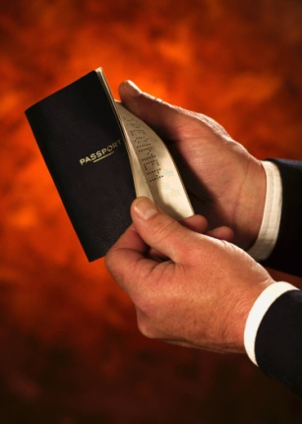
- Photographic Drivers Licence
- Passport
- Proof of age card
- Identification booklet.
Checking identification
Some people are very clever at producing genuine looking identification.
Even if you are provided with an identification that appears real, the organisation and the individual server may still be found to be legally responsible if that person turns out to be a minor.
Therefore carefully checking identifications is important. Tips when checking identifications include:
- Always check them in a well-lit area
- Take the time to examine the identification carefully

- Look for any signs that may indicate the identification is not real including:

- Alternations of pages
- Changing of photos
- Changing of date
- Ask for supporting identification is you are unsure of the authenticity of the identification
- Get the person to sign a document to compare signatures or to state the document is accurate
- Ask questions to test the authenticity of information on the identification.
Handling fake identification
If you think that a person has given you a fake identification it is good practice to:
- Refuse the person entry
- Keep the identification
- Give the identification to the relevant authorities.
Observe drinkers
In many establishments, minors are allowed into a wide variety of food and beverage outlets that serve both food and/or beverage.
Staff should observe people who are drinking alcohol. In some cases, adults may have purchased these drinks on their behalf.

3.4 Comply with legislative requirements

Introduction
All businesses that serve food and beverage will have a series of laws in which they must comply.
Some of these laws have previously been discussed in this manual to date, however there are many more which are just as important and must be understood and complied with by all staff within an organisation.
Licensing law is the set of legal rules governing the sale of alcohol in a given jurisdiction. It usually defines who can sell alcohol, when, where and to whom. Generally the underlying purpose of licensing law is to act as a protection against any potential harm to public order or to public health. This is sometimes stated in the law.

Types of legislation
As previously mentioned, each country will have their own laws and regulations that must be complied with. Please refer to any specific laws that may relate to your country.
Some generic laws relating to the sale and supply of alcohol includes:

License to sell
Most countries that have restrictions on who can buy alcohol, will also have restrictions on who can do the selling.
In order to sell alcohol, you may have to obtain a permit or license.
The license may simply permit you to sell alcohol in general or may have stipulations including:
- In which areas of the establishment it may be sold
- What may be sold – for consumption within the establishment or to be taken off the premises
- At what times sales can be made
- If alcohol is allowed to be brought into the venue for consumptions.
Establish policies and procedures
- Establish house rules
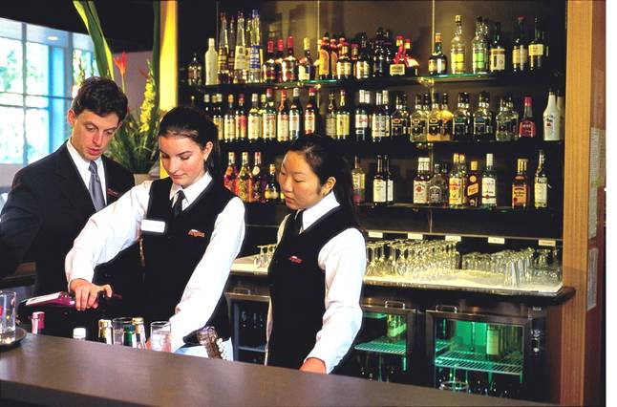
- Place appropriate signs in place.
Training of staff
Management may need to ensure:
- Correct types of staff – including security
- Correct numbers of staff
- Correct age of staff serving alcohol.

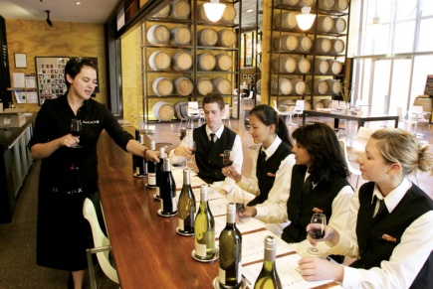
Staff may be required to:
- Undertake responsible service of alcohol courses
- Gain certification in specific courses
- Attend regular staff meetings to discuss RSA issues
- Understand their responsibilities
- Be properly trained and consistently apply their training and knowledge of RSA in the workplace.
Documentation of systems
In order to prove that you are complying with the laws, it is good practice to keep records to show what systems you have in place:
1. Training and Training Records
It is good practice for employers to show that staff have been made aware of the laws through training and by asking staff to sign to show they have understood these laws, or to sit an exam to prove their understanding.
2. Incident Diary
It is good practice to record any incidents that happen, such as arguments or fights, so that any problems can be identified to prevent them from occurring again. It also gives an accurate picture for company communication and passing on to any authorities that may need details.
The current diary should be kept in a handy place where everyone knows where to find it. Old records should be filed for possible use in any legal actions that may follow.
3. Refusals Book
This is a book where you record when you have to refuse service because customers are underage, drunk, etc. This record book is then signed by the manager and shows you are abiding by the laws. It also helps to build a picture of any problem patterns.
Recording Incidents
You should record all incidents for a variety of reasons:
- It can be used as a learning tool and can assist in communication between staff and management
- It provides an accurate record for police, company or insurance purposes
- It can help prevent similar incidents from happening again.
The record should include the following:
- Date
- Time
- What happened
- Who was involved
- How it was dealt with
- Whether police were called
- You may also wish to record the names of any witnesses and their contact information.
Work Projects
It is a requirement of this Unit you complete Work Projects as advised by your Trainer. You must submit documentation, suitable evidence or other relevant proof of completion of the project to your Trainer by the agreed date.
3.1 To fulfil the requirements of this Work Project you are asked to research and identify how to assess situations including:
Responsible & legal considerations.
3.2 To fulfil the requirements of this Work Project you are asked to research and identify how to deal with intoxicated persons appropriately.
3.3 To fulfil the requirements of this Work Project you are asked to research and identify how to deal with underage drinkers including:
Reasons for law
Conditions for law
Strategies to prevent underage drinking.
3.4 To fulfil the requirements of this Work Project you are asked to research and identify how to comply with legislative requirements including:
Types of legislation.

Summary

Comply with legislation
Assess situations
Responsible & legal considerations.
Deal with intoxicated persons appropriately
Tips to remember.
Deal with underage drinkers
Reasons for law
Conditions for law
Strategies to prevent underage drinking.
Comply with legislative requirements
Types of legislation.

Presentation of written work

1. Introduction
It is important for students to present carefully prepared written work. Written presentation in industry must be professional in appearance and accurate in content. If students develop good writing skills whilst studying, they are able to easily transfer those skills to the workplace.

2. Style

Students should write in a style that is simple and concise. Short sentences and paragraphs are easier to read and understand. It helps to write a plan and at least one draft of the written work so that the final product will be well organised. The points presented will then follow a logical sequence and be relevant. Students should frequently refer to the question asked, to keep ‘on track’. Teachers recognise and are critical of work that does not answer the question, or is ‘padded’ with irrelevant material. In summary, remember to:
- Plan ahead
- Be clear and concise
- Answer the question
- Proofread the final draft.

3. Presenting Written Work
Types of written work
Students may be asked to write:
- Short and long reports
- Essays
- Records of interviews
- Questionnaires
- Business letters
- Resumes.
Format
All written work should be presented on A4 paper, single-sided with a left-hand margin. If work is word-processed, one-and-a-half or double spacing should be used. Handwritten work must be legible and should also be well spaced to allow for ease of reading. New paragraphs should not be indented but should be separated by a space. Pages must be numbered. If headings are also to be numbered, students should use a logical and sequential system of numbering.
Cover Sheet
All written work should be submitted with a cover sheet stapled to the front that contains:
- The student’s name and student number
- The name of the class/unit
- The due date of the work
- The title of the work
- The teacher’s name
- A signed declaration that the work does not involve plagiarism.
Keeping a Copy
Students must keep a copy of the written work in case it is lost. This rarely happens but it can be disastrous if a copy has not been kept.
Inclusive language
This means language that includes every section of the population. For instance, if a student were to write ‘A nurse is responsible for the patients in her care at all times’ it would be implying that all nurses are female and would be excluding male nurses.
Examples of appropriate language are shown on the right:
Mankind | Humankind
Barman/maid | Bar attendant
Host/hostess | Host
Waiter/waitress | Waiter or waiting staff

Recommended reading
Department of Treasury and Finance; 2012 (3rd edition); Responsible Service of Alcohol Tasmania; Tasmania Government
Dugan, Beth; 2005 (1st edition); The Responsible Serving of Alcoholic Beverages: A Complete Staff Training Course for Bars, Restaurants and Caterers; Atlantic Publishing Company
Plotkin, Robert; 1988 (1st edition); Intervention Handbook: The Legal Aspects of Serving Alcohol; Barmedia
Various authors; 2012; Responsible Service of Alcohol: A Server’s Guide; International Center for Alcohol Policies (ICAP) and the European Forum for Responsible Drinking (EFRD)
Victorian Commission for Gambling and Liquor Regulation; 2012; A Guide to the Responsible Service of Alcohol; Victoria Government

Trainee evaluation sheet

Manage intoxicated persons
The following statements are about the competency you have just completed.
Please tick the appropriate box | Agree | Don’t Know | Do Not Agree | Does Not Apply
There was too much in this competency to cover without rushing.
Most of the competency seemed relevant to me.
The competency was at the right level for me.
I got enough help from my trainer.
The amount of activities was sufficient.
The competency allowed me to use my own initiative.
My training was well-organised.
My trainer had time to answer my questions.
I understood how I was going to be assessed.
I was given enough time to practice.
My trainer feedback was useful.
Enough equipment was available and it worked well.
The activities were too hard for me.
The best things about this unit were:

The worst things about this unit were:

The things you should change in this unit are:

Trainee self-assessment checklist
As an indicator to your Trainer/Assessor of your readiness for assessment in this unit please complete the following and hand to your Trainer/Assessor.

Manage intoxicated persons
 |  | Yes | No*
Element 1: Determine the level of intoxication
1.1 | Assess intoxication levels of customers
1.2 | Offer assistance to intoxicated customers politely
1.3 | Refer difficult situations to an appropriate person within or outside of the establishment
1.4 | Seek assistance from appropriate people for situations which pose a threat to safety or security of colleagues, customers or property
Element 2: Apply appropriate procedures
2.1 | Analyse situation carefully
2.2 | Apply procedures appropriate to the situation and in accordance with organisational policy
2.3 | Explain the position to the customer using appropriate communication skills
2.4 | Assist the guest/customer to leave the premises if necessary
Element 3: : Comply with legislation
3.1 | Assess situations
3.2 | Deal with intoxicated persons appropriately
3.3 | Deal with underage drinkers
3.4 | Comply with legislative requirements

Statement by Trainee:
I believe I am ready to be assessed on the following as indicated above:
Signed: _____________________________ | Date: ____________

Note:
For all boxes where a No* is ticked, please provide details of the extra steps or work you need to do to become ready for assessment.





